**OOP LAB**

**Session 4**

**Part I**

**Lab No. 9:** Generics

Lab Exercises

1. Write a generic method to exchange the positions of two different elements in an array.
2. Define a simple generic stack class and show the use of the generic class for two different class types Student and Employee class objects.
3. Write a program to demonstrate the use of wildcard arguments.

**Part II**

**Lab No. 11 and 12:** JavaFX and Event Handling

Lab Exercises

* 1. Write a JavaFX application program to do the following:
     1. Display the message “Welcome to JavaFX programming” using Label in the Scene.
     2. Set the text color of the Label to Magenta.
     3. Set the title of the Stage to “This is the first JavaFX Application”.
     4. Set the width and height of the Scene to 500 and 200 respectively.
     5. Use FlowPane layout and set the hgap and vgap of the FlowPane to desired values.
     6. The program will accept an integer from the user in a text field and display the multiplication table (up to number *10) for that number.
  2. 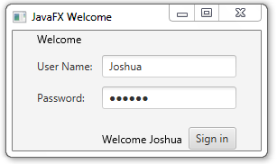Write a JavaFX program to display a window as shown below. Use TextField for UserName and PasswordField for Password input. On click of “Sign in” Button the message “Welcome UserName” should be displayed in a Text Control. Use GridPane layout for the application.

## Fig 1: Welcome Window

* 1. Write a JavaFX application program that obtains two floating point numbers in two text fields from the user and displays the sum, product, difference and quotient of these numbers using Canvas on clicking compute button with a calculator image placed on it

**\*\*\*\*\*\*\*\*\*\*\*\*\*\***